**Report Final Project SSIP**

1. Mohammad Waarits Harahap (001202400025)
2. Navisa Ersa Sabina (001202400083)
3. Janet Dewi Evangeline (001202400146)

# **Overview**

## Our project is a web-based application that allows users to browse and purchase event tickets. Built using Laravel, the system supports both regular users and event organizers with role-based access. It provides functionalities to manage users, events, venues, ticket types, and orders, ensuring smooth ticket booking and event management.

# **Functional Requirements**

1. **Regular Users**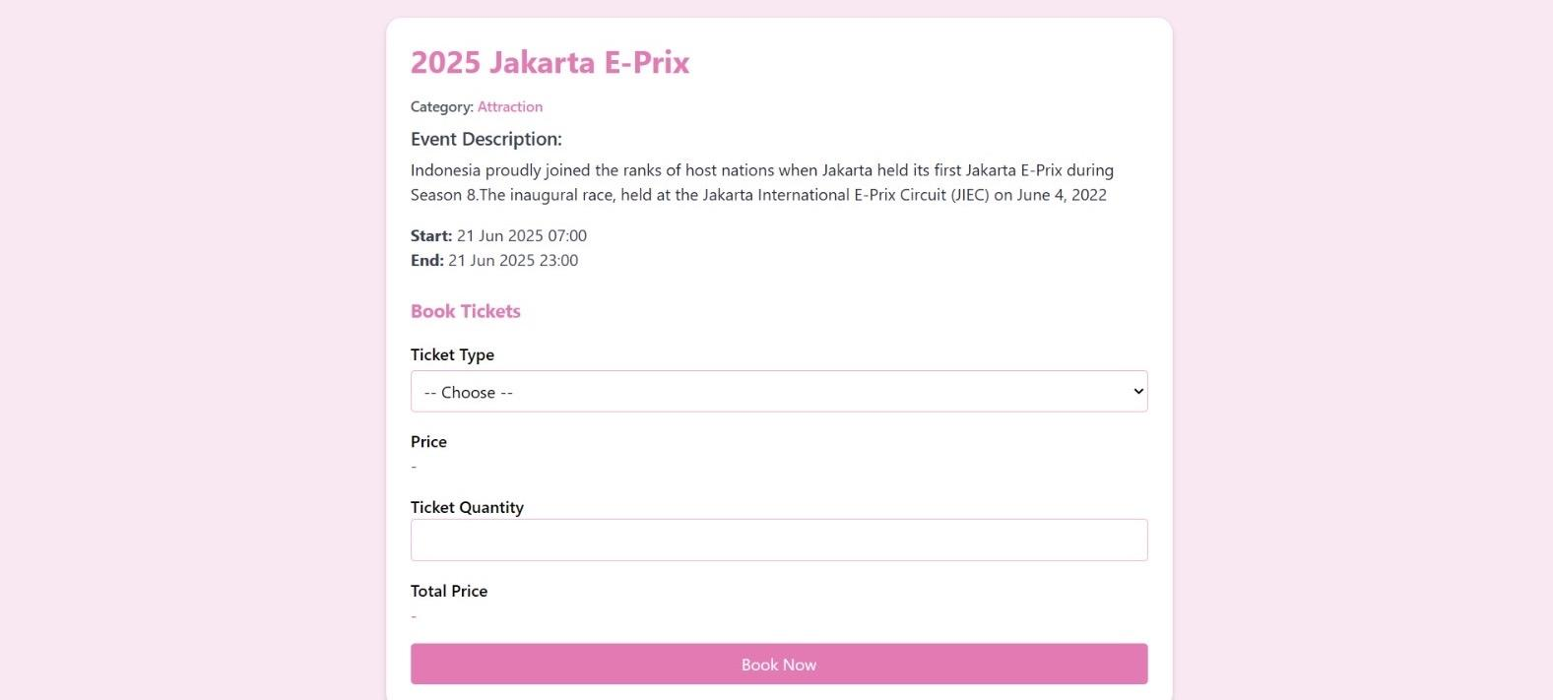

## Users of the platform are able to:

* Register an account with their full name, email, phone number, and password.
* Log in to access the platform.
* View a list of available events, with filters by event name, category, and price range.
* View event details such as:

1. Title, description, start and end date/time
2. Ticket types and their prices
3. Event category

* Choose ticket type and quantity, then proceed with the booking process.
* View their order history, including:

1. Event name, date, venue
2. Ticket type and quantity
3. Total price

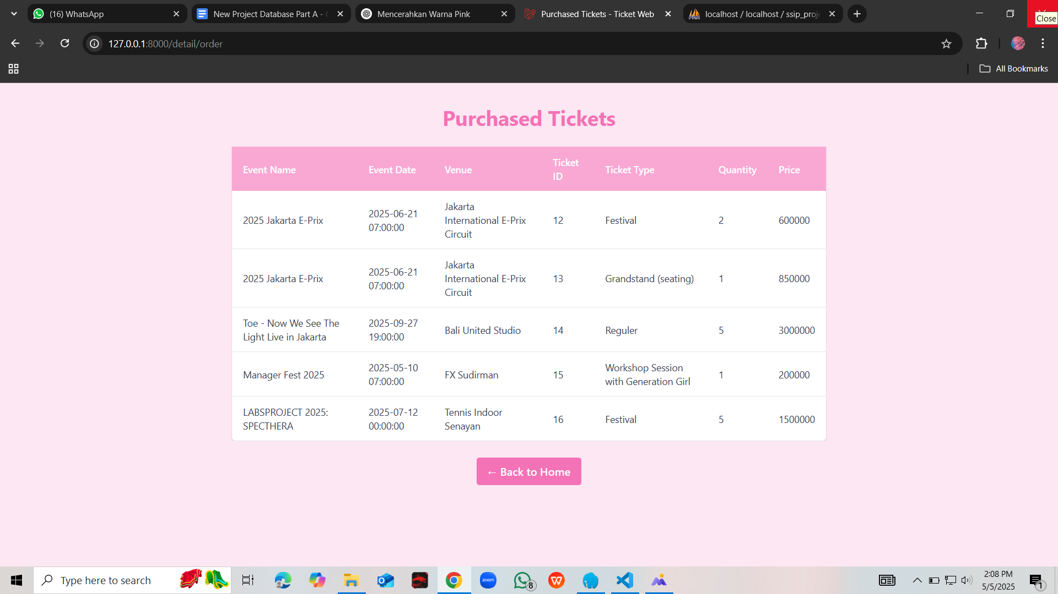

1. **Organizers and Admins**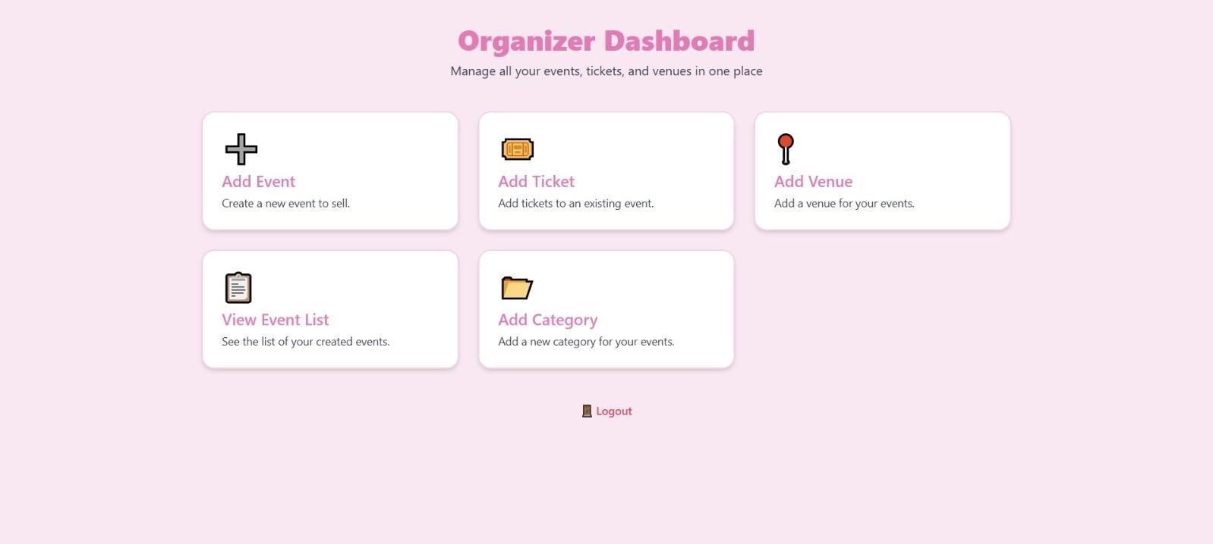

## 

## Event organizers or admins have extended access and can:

* Create and manage event records (add, edit, delete).
* Set event details, including title, description, date and time, and associated venue and category.
* Add ticket types, including names, prices, and quotas.
* Create and manage venues, including name, location, and capacity.
* Create and manage event categories.
* Monitor the list of all events created.

## **Admin Dashboard – CRUD Features**

## The Admin/Organizer Dashboard supports full **CRUD** operations for event management:

| **Feature Area** | **Create** | **Read** | **Update** | **Delete** |
| --- | --- | --- | --- | --- |
| **Events** | Add new events with title, description, date, venue, category | View list and details of events | Edit event data such as name, description, time | Delete events |
| **Venues** | Add new venues with name, address, and capacity | View list of venues | Edit venue information | Delete venues |
| **Ticket Types** | Define ticket types for each event | View ticket pricing and quota | Update ticket price or name | Delete ticket types |
| **Categories** | Create event categories | View and assign categories to events | Update category name | Delete categories |

## 

## 

## **Relational Tables Explanation**

## | **venues** | - One venue can be used in many events |

## | **venues** | - One venue can be used in many events | | **events** |

## Belongs to one venue and one category

## Has many ticket types

## Has many orders

## Created by one user (organizer)

## Can be referenced by many orders |

## |**categories** | - One category can be linked to many events | | **tickettypes** |

* Belongs to one event

## Can be referenced by many orders |

## | **orders** |

## Belongs to one user, one event, and one ticket type

## Stores ticket quantity and unit price |

## 

## **Foreign Key Relationships**

* events.venue_id → [venues.id](http://venues.id)
* events.category_id → [categories.id](http://categories.id)
* events.user_id → [users.id](http://users.id)
* tickettypes.event_id → [events.id](http://events.id)
* orders.user_id → [users.id](http://users.id)
* orders.event_id → [events.id](http://events.id)
* orders.ticket_types_id → [tickettypes.id](http://tickettypes.id)

## **Business Rules Summary**

1. **Unique Email**: No duplicate emails allowed.

## **Valid Event Links**: Events must have a valid venue and category.

## **Ticket Quota**: Cannot sell more than available tickets.

## **Valid Orders**: Orders must reference valid users, events, and ticket types.

## **Correct Total Price**: Total = price × quantity.

## **Access Control**: Users see only their own orders. Admins manage all data.

## **Role Permissions**:

* user: can browse and buy tickets
* organizer / admin: can manage data

1. **Data Integrity**: Uses cascading deletes to maintain consistency.
2. **Additional Functional Feature**
3. **Search Feature**:  
   Users can search for events by name using a search bar.
4. **Filter Feature**:  
   Users can filter events based on:

* **Category** (e.g., music, conference, workshop)
* **Price range** (min to max ticket price)

1. **Conclusion**

## This ticketing system offers a comprehensive and structured solution for both users and event organizers. It provides a complete event management workflow with user-friendly interfaces, search and filter functions, full CRUD features, and a strong relational database structure to ensure data integrity and a smooth experience for all users.

## 